IRIS Client Sync Plug-ins

Contents

Overview 1
Export Plug-ins 1
Import Plug-ins 4
Technical Details 5
Exporter COM Automation Object 5
DoExport(DataPath, XMLPath, Param1, Param2, Param3, Param4, UserReference) 5
Get_XMLCount 5
Get_XMLList(Index: Integer) 6
Export Manager 6
function BeforeExport(TableID: LongWord; Params: TExportParams): Boolean; virtual; 6
function GetTableExporter(pReference: Longword): _ExportBase; virtual; 6
procedure ClearXMLList; 6
function ExportTable(TableID: LongWord; Params: TExportParams): LongWord 6
function Get_XmlCount: Integer 6
function Get_XmlList(Index: Integer): WideString 6
Exporter 6
Importer COM Automation Object 7
function DoImport(DataPath, XML, XSL, XSD, UserReference): LongWord 7
Importer 7
Projects, Units, and Classes 11
System Export Plugin (ICEExSys.DLL) 11
Static Export Plugin (ICEExSta.DLL) 11
Transaction Export Plugin (ICEExSta.DLL) 11
Matching Export Plugin (ICEExMat.DLL) 12
DripFeed Export Plugin (ICEExMat.DLL) 12
System Import Plugin (ICSImSys.DLL) 12
Static Import Plugin (ICSImSta.DLL) 13
Transaction Import Plugin (ICSImTra.DLL) 13
Matching Import Plugin (ICSImMat.DLL) 13
DripFeed Import Plugin (ICSImDri.DLL) 14
Notes 15
Document Numbers 15
Identifying Transaction Source 15
Identifying Transactions for Export 15
Source File Directories 16

Overview
The Client Sync plug-ins are used by the DSR to export and import data from the IRIS database files.

All the plug-ins are implemented as OLE Automation servers. The Export plug-ins have three publicly available methods:

- DoExport(), which actually does the export;

- Get_XMLCount(), which returns the number of records that were exported;

- Get_XMLList(), which returns either the actual XML for one record, or else the file name of the XML file for the record.

The Import plug-ins only have one publicly available method, DoImport().

Export Plug-ins
There are five export plug-ins, each with its own OLE Automation server for the specific files or record sets:

DLL | Automation Server | Exports
ICSExSys.dll | IrisClientSync.SystemDataExporter | Cost Centres  Departments  Currency Rates  Document Numbers  GL Codes  System Settings  VAT Rates  User-defined Periods
ICSExSta.dll | IrisClientSync.StaticDataExporter | Customers  Suppliers  GL Structure  Stock Groups & Items
ICSExTra.dll | IrisClientSync.TransactionDataExporter | Transactions  Transaction History
ICSExMat.dll | IrisClientSync.MatchingDataExporter | Matching Records
ICSExDri.dll | IrisClientSync.DripfeedDataExporter | Cost Centres  Departments  Customers  Suppliers  Stock Groups & Items  Transactions  Matching Records

The DSR has a configuration file which tells it which plug-in is required for which Export type. It uses this to determine which plug-in to activate, and it creates the OLE Automation object provided by the plug-in.

It then calls the DoExport() method, passing the IAO installation path, the folder into which XML files are to be stored (for tables which export to file rather than directly to the DSR), and the start and end period parameters where necessary.

In the DoExport() method, the Data Exporter (the OLE Automation object) creates the appropriate Export Manager -- each plug-in has its own Export Manager, but they are all descended from a base Export Manager class which provides most of the required functionality.

The Export Manager creates instances of the Exporters for each table to be exported, and passes each of these in turn to the ExportTable method, which then sets up the Exporters with the required parameters (paths, periods, etc), and calls the LoadFromDB() method on the Exporters, which then gather the data from the tables.

The Exporters either save the XML documents into a list, or they save each XML document to a file, and record the filename in a string-list instead.

On return from the LoadFromDB() method, the Export Manager determines whether the XML is in internal documents or is saved to file. In the case of internal documents, it copies the actual XML strings from the documents into a string-list. Where the documents were saved to file it instead copies the filenames into a string-list.

The DSR can then interrogate the Exporter to retrieve the XML strings or file names.

Figure 1 below gives a simplified view of the overall process, from the point where the DSR calls the plug-in.
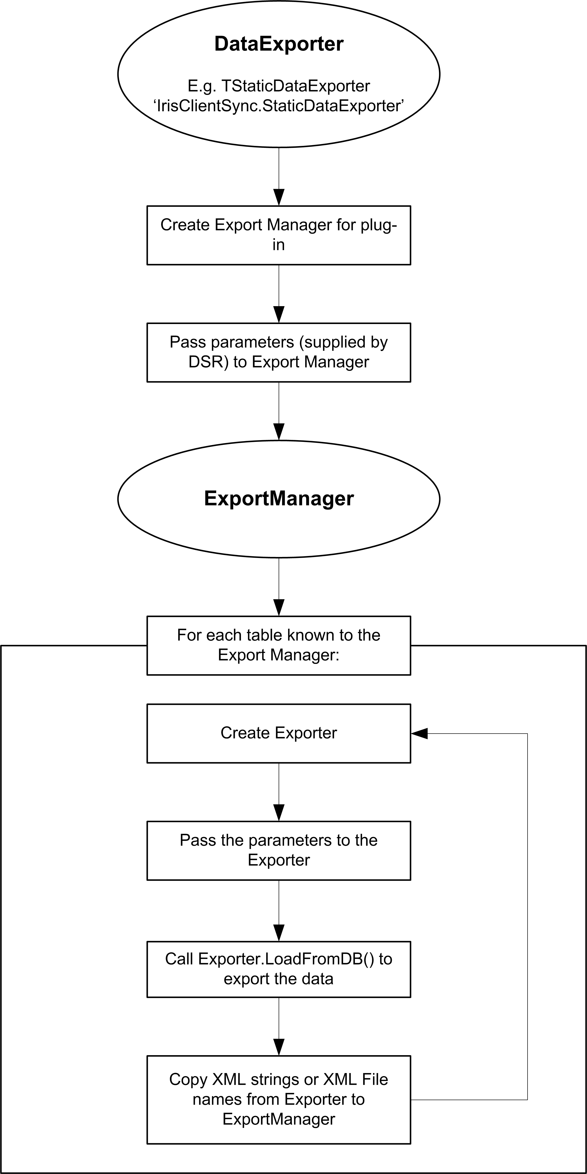

Figure 1

Import Plug-ins
There are five import plug-ins, each with its own OLE Automation server for the specific files or record sets:

DLL | Automation Server | Imports
ICSImSys.dll | IrisClientSync.SystemDataImporter | Cost Centres  Departments  Currency Rates  Document Numbers  GL Codes  System Settings  VAT Rates  User-defined Periods
ICSImSta.dll | IrisClientSync.StaticDataImporter | Customers  Suppliers  GL Structure  Stock Groups & Items
ICSImTra.dll | IrisClientSync.TransactionDataImporter | Transactions  Transaction History
ICSImMat.dll | IrisClientSync.MatchingDataImporter | Matching Records
ICSImDri.dll | IrisClientSync.DripfeedDataImporter | Cost Centres  Departments  Customers  Suppliers  Stock Groups & Items  Transactions  Matching Records

The DSR has a configuration file which tells it which plug-in is required for which Export type. It uses this to determine which plug-in to activate, and it creates the OLE Automation object provided by the plug-in.

It then calls the DoImport() method for each XML record, passing the IAO installation path, and either the path to the XML file, or the XML string itself.

In the DoImport() method, the Data Importer creates an instance of the appropriate Importer, having read the Import type from the XML header. It sets up the Importer with the data path, and then calls the Importer’s Extract() method to retrieve the data from the XML and store into the IAO database.

Note
The Import plug-in has no equivalent of the Export Manager, because the process of creating and calling the Importer is simpler than the equivalent for exporting, so a Manager class seemed unnecessary.

Technical Details
See Figure 2 for a diagram of the class hierarchy used by the Export plug-ins.

See Figure 3 for a diagram of the class hierarchy used by the Import plug-ins.

The plug-ins vary slightly in how they work, but they all conform to approximately the same pattern, and use a standard set of the base classes.

The classes in the diagram whose titles are enclosed in square brackets have different versions in each of the plug-ins.

Exporter COM Automation Object
The Static exporter will be taken as an example, as it uses most of the features found in the other plug-ins.

As with all the plug-ins, the Static exporter is a COM Automation object. The library name, which is used to identify the correct COM object when it needs to be created, is IrisClientSync.StaticDataExporter. All the plug-ins share the IrisClientSync name, and change the second part of the name as appropriate.

By convention, all the exporter units are called oExporter.pas (as each oExporter.pas is in a different project, there is no conflict).

The main exporter class, TStaticDataExporter in the case of the Static exporter, implements the IExportBox interface, found in the ExportBox project.

Note
ExportBox is itself a registered COM object (DSRExport.dll), even though it is never directly used. It has to be a registered COM object in order for the interface to be available to the type libraries of the plug-ins.

There are three methods in this interface:

DoExport(DataPath, XMLPath, Param1, Param2, Param3, Param4, UserReference)
This is the main entry-point.

Parameter | Type | Purpose
DataPath | WideString | Path of the Exchequer installation
XMLPath | WideString | Folder containing the model XML files.
Param1 | OleVariant | Additional filter details (normally the start and end period and year for the export).
Param2 | OleVariant
Param3 | OleVariant
Param4 | OleVariant
UserReference | LongWord | Identifies a specific table for export. If 0 is passed as this parameter, it will export all the tables known to the plug-in.

For convenience these parameters are copied into a TExportParams object, which is then passed around to any other objects that need access to them.

DoExport uses the Export Manager (see below) to carry out the actual export.

Get_XMLCount
This returns a count of the number of records actually exported. Obviously, it is only valid after DoExport has been called.

This actually calls the equivalent method in the Export Manager to get the correct value.

Get_XMLList(Index: Integer)
This returns a specified entry from the list of exported records. Depending on the table(s) which has been exported, this can either be the filename of an XML file, or a string containing the XML itself.

Note that if pUserReference was passed as 0, and the plug-in handles multiple tables, Get_XMLList can return different types of result for different entries.

Export Manager
All the plug-ins work by having an Export class for each table (or in some cases, groups of tables). When the plug-in needs to carry out an export, it creates an instance of each class in turn, sets up the correct parameters for it, calls a standard method on the class for doing the actual export, then retrieves the resulting list of XML files of XML strings ready for return to the DSR.

This process is identical for every table and every plug-in, the only variation being in the actual Export classes created. To avoid duplicating code in each plug-in, there is a TBaseExportManager class which provides the necessary functionality through an ExportTable() method.

TBaseExportManager methods

function BeforeExport(TableID: LongWord; Params: TExportParams): Boolean; virtual;
This virtual method is called from the main ExportTable method, and can be overridden if the descendant Export Manager needs to provide some additional set-up just before calling the LoadFromDB method of the actual Export object.

function GetTableExporter(pReference: Longword): _ExportBase; virtual;
This virtual method is overridden by all the descendant classes, and returns the appropriate Export object for the table (or group of tables) indicated by the pReference parameter.

(There are constants set up for pReference, in uConsts.pas in the Common directory.)

procedure ClearXMLList;
Clears any existing entries in the exported list of XML files or strings.

function ExportTable(TableID: LongWord; Params: TExportParams): LongWord
This is the main entry point for this class. The Data Exporter will call this method to do the actual export. It uses GetTableExporter, passing the TableID as the identifier, to get the required Export object, sets up the Export object using the supplied parameters, calls the Export.LoadFromDB method to do the actual exporting, and finally copies the results into the appropriate output list.

It returns 0 for success, or an appropriate error number (error numbers are defined in uConsts.pas in the Common directory).

function Get_XmlCount: Integer
The Get_XMLCount method of the Data Exporter maps down onto this method, which returns the number of records exported.

function Get_XmlList(Index: Integer): WideString
The Get_XMLList method of the Data Exporter maps down onto this method, which returns the specified entry from the list.

Exporter
The exporter classes are responsible for actually connecting to the database files, retrieving the required records, and building the XML from them. All the exporters descend from the _ExportBase class, mainly overriding the LoadFromDB method which is the main entry point.

For retrieving data, most of the Exporters read directly from the database. For convenience, however, some (such as the System Settings Exporter) use the COM Toolkit.

Writing the XML is normally done using TXMLDoc, which is a class based on Microsoft’s XML Parser. For some files, notably Transactions, an alternative TXMLWriter class is used instead, mainly for performance reasons.

Importer COM Automation Object
The Static importer will be taken as an example, as it uses most of the features found in the other plug-ins.

As with all the plug-ins, the Static importer is a COM Automation object. The library name, which is used to identify the correct COM object when it needs to be created, is IrisClientSync.StaticDataImporter. All the plug-ins share the IrisClientSync name, and change the second part of the name as appropriate.

By convention, all the importer units are called oImporter.pas (as each oImporter.pas is in a different project, there is no conflict).

The main importer class, TStaticDataImporter in the case of the Static importer, implements the IImportBox interface, found in the ImportBox project.

Note
ImportBox is itself a registered COM object (DSRImport.dll), even though it is never directly used. It has to be a registered COM object in order for the interface to be available to the type libraries of the plug-ins.

There is only one method in this interface:

function DoImport(DataPath, XML, XSL, XSD, UserReference): LongWord
This is the main entry-point.

Parameter | Type | Purpose
DataPath | WideString | Path of the Exchequer installation
XML | WideString | Either the actual XML data as a string, or the full path and file name of the XML file to be imported.
XSL | WideString | Not used
XSD | WideString | Not used
UserReference | LongWord | Identifies a specific table for export. If 0 is passed as this parameter, it will export all the tables known to the plug-in.

Each Data Importer also implements a protected method GetTableImporter() which take the table ID (UserReference) as a parameter, and creates the actual Importer class for handling the import of the individual tables.

DoImport assigns the XML and the data path to the Importer, and calls the Extract method of the Importer to do the actual import.

Importer
The importer classes are responsible for actually connecting to the database files, and copying the data from the XML records into the appropriate files. All the exporters descend from the _ExportBase class, mainly overriding the AddRecord method which is called by the Extract method of the ancestor class, the main entry point.

Some of the Importers write directly into the database. Other, such as the Transactions Importer, use the COM Toolkit, to ensure that all the necessary files are updated when new records are added.

Reading the XML is done using TXMLDoc, which is a class based on Microsoft’s XML Parser. The Extract method reads each XML record in turn (though most import XML files only contain one record each), and calls the AddRecord method, passing the current XML node to it, to copy the data and store it in the database file.

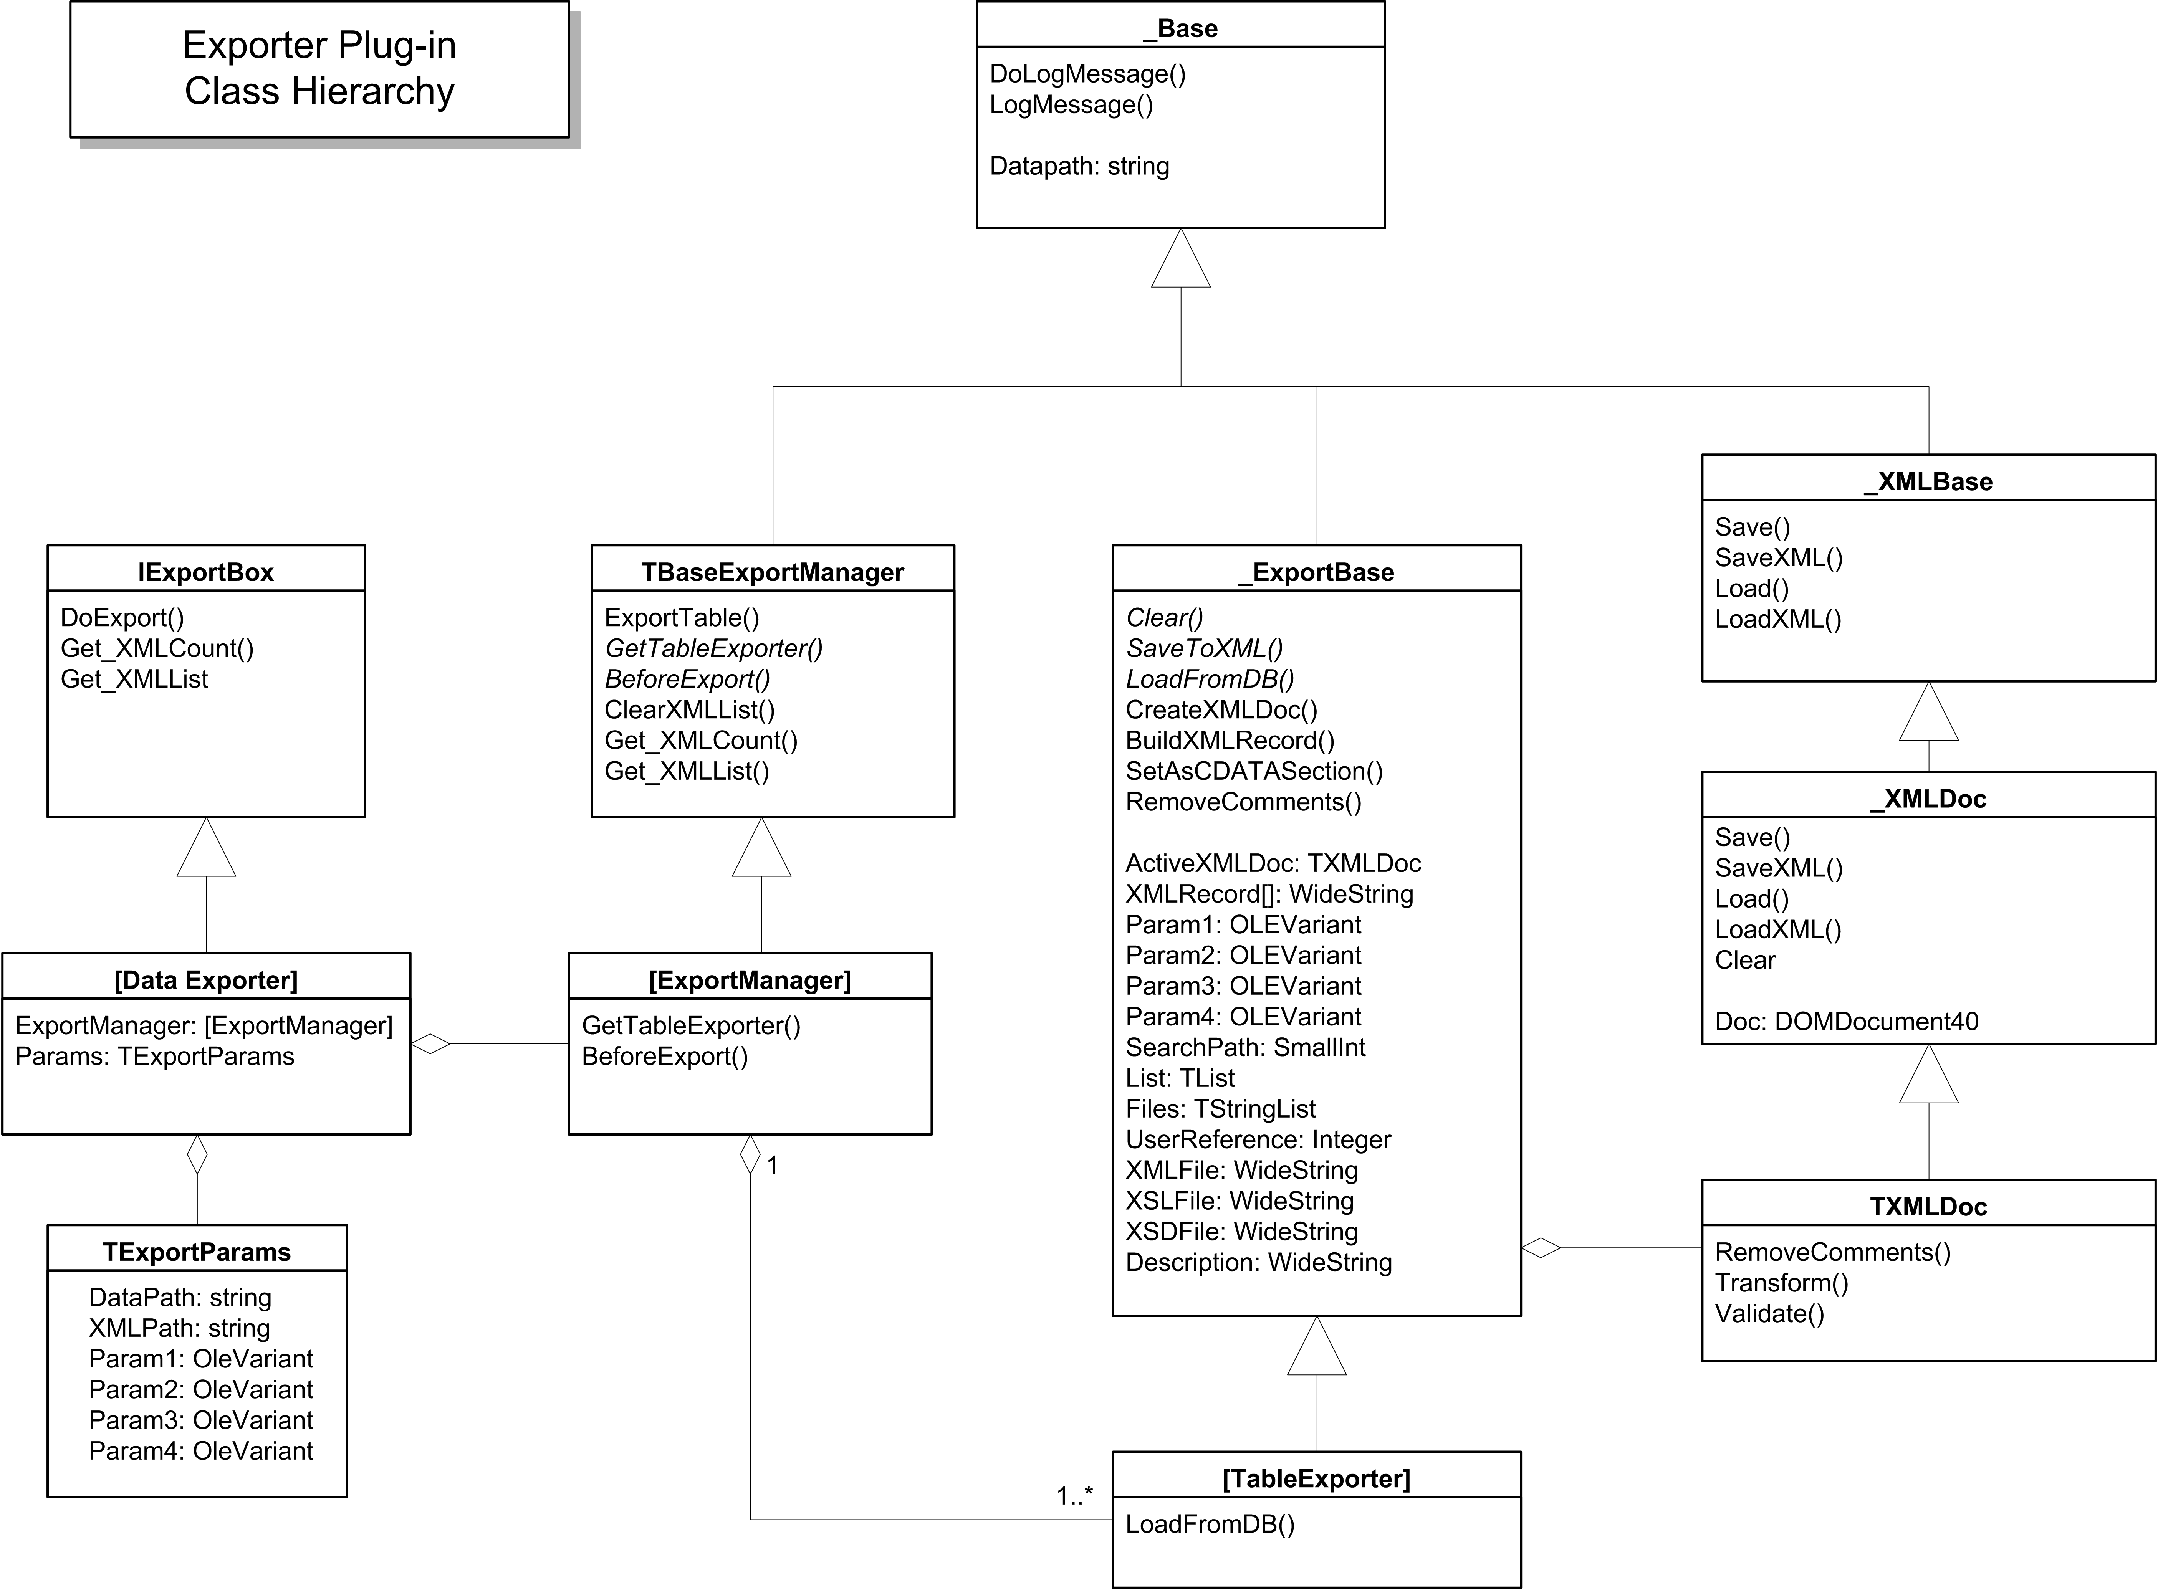

Figure 2

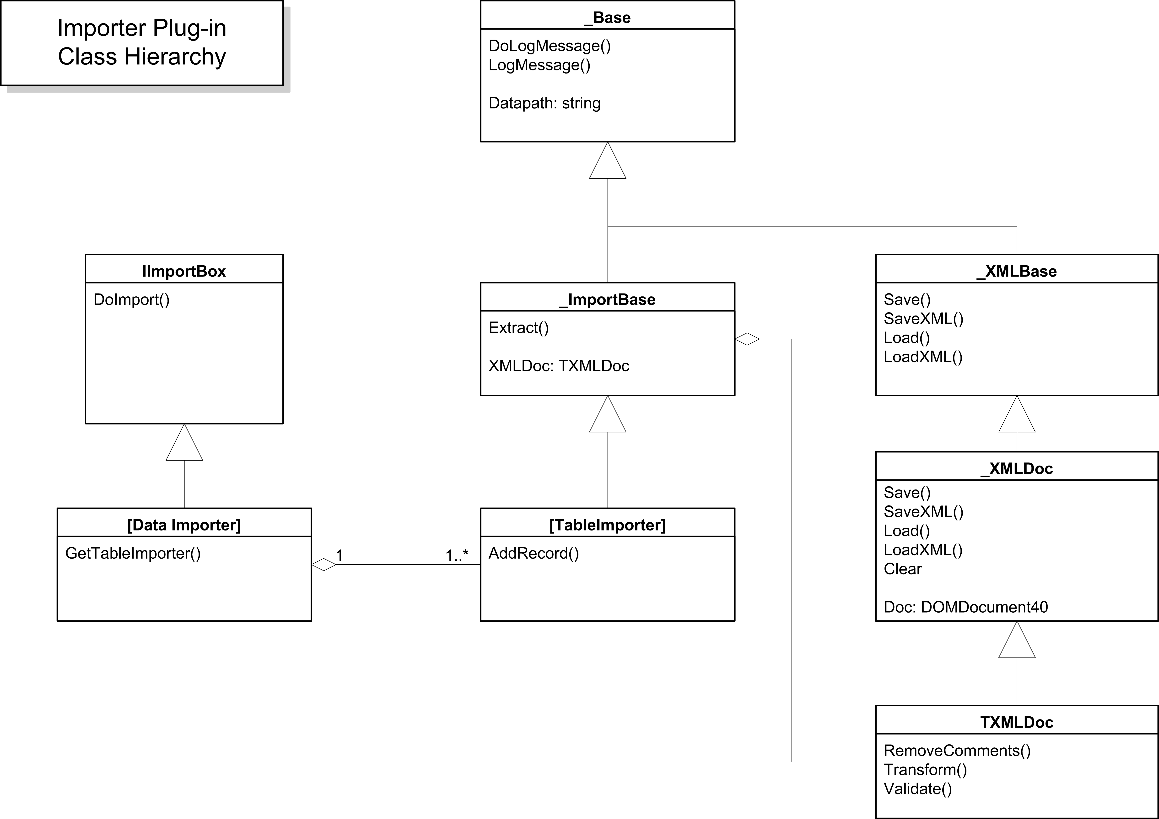

Figure 3

Projects, Units, and Classes

System Export Plugin (ICEExSys.DLL)
\EXCHLITE\ICE\Source\Export\System\ICSExSys.dpr

Unit | Class
oExporter.pas | TSystemDataExporter | COM Object (IrisClientSync.SystemDataExporter)
uSystemExportManager.pas | TSystemExportManager | Class to manage the exporters for the individual tables.
uCCDeptExport.pas | TCCDeptExport | Exporter for Cost Centre and Departments (has an ImportType property to specify which one is being exported).
uCurrencyExport.pas | TCurrencyExport | Exporter for currency types.
uDocNumberExport.pas | TDocNumberExport | Exporter for Document Numbers.
uGLCodeExport.pas | TGLCodeExport | Exporter for GL Codes.
uSystemSettingsExport.pas | TSystemSettingsExport | Exporter for System Settings.
uVATExport.pas | TVATExport | Exporter for VAT set-up.
uPeriodExport.pas | TPeriodExport | Exporter for User-defined Periods.
uVersionExport.pas | TVersionExport | Exporter for Version/Product details.

Static Export Plugin (ICEExSta.DLL)
\EXCHLITE\ICE\Source\Export\Static\ICSExSta.dpr

Unit | Class
oExporter.pas | TStaticDataExporter | COM Object (IrisClientSync.StaticDataExporter)
uStaticExportManager.pas | TStaticExportManager | Class to manage the exporters for the individual tables.
uCustExport.pas | TCustExport | Exporter for Customers and Suppliers. The ExportType property determines whether Customers (csExportCustomers) or Suppliers (csExportSuppliers) are exported.  They are exported to different XML files, but with identical structures.
uGLStructureExport.pas | TGLStructureExport | Exporter for the GL Structure records.
uStockExport.pas | TStockExport | Exporter for Stock Items and Stock Groups.

Transaction Export Plugin (ICEExSta.DLL)
\EXCHLITE\ICE\Source\Export\Transactions\ICSExTra.dpr

Unit | Class
oExporter.pas | TTransactionDataExporter | COM Object (IrisClientSync.TransactionDataExporter)
uTransactionExportManager.pas | TTransactionExportManager | Class to manage the exporters for the individual tables.
uTransactionExport.pas | TTransactionExport | Exporter for Transaction records.
uHistoryExport.pas | THistoryExport | Exporter for Transaction History records.
uICEDripFeed.pas | TICEDripFeed | Provides access to the Drip Feed details stored for the current company.
uTransactionTracker.pas | TTransactionTracker | Class to detect transactions which have been added since the last import.
uXMLWriter.pas | TXMLWriter | Simple XML generator class, used instead of TXMLDoc for performance reasons.
uXMLFileManager.pas | TXMLFileManager | Class for outputting XML to file, automatically assigning unique filenames for them.

Notes
Once a transaction export has successfully completed, the Transaction Tracker and ICE Drip Feed objects take a copy of the current set of ‘last used’ document numbers, and switch the company into Drip-Feed mode, recording the start and end periods to be covered.

The Drip Feed export will use the start and end period information to determine which transactions need to be included.

Matching Export Plugin (ICEExMat.DLL)
\EXCHLITE\ICE\Source\Export\Matching\ICSExMat.dpr

Unit | Class
oExporter.pas | TMatchingDataExporter | COM Object (IrisClientSync.MatchingDataExporter)
uMatchingExportManager.pas | TMatchingExportManager | Class to manage the exporters for the individual tables.
uMatchingExport.pas | TMatchingExport | Exporter for Matching records.

DripFeed Export Plugin (ICEExMat.DLL)
\EXCHLITE\ICE\Source\Export\DripFeed\ICSExDri.dpr

Unit | Class
oExporter.pas | TDripFeedDataExporter | COM Object (IrisClientSync.DripFeedDataExporter)
uDripFeedExportManager.pas | TDripFeedExportManager | Class to manage the exporters for the individual tables.
uDripFeedExport.pas | TDripFeedExport | Exporter for DripFeed records. (Cost Centre, Department, Stock Items, Transaction, Transaction Lines)
uTransactionTracker | TTransactionTracker | Class for keeping track of transactions which need to be exported.

Notes
The Drip-Feed exporter builds an XML file which contains all the records relevant to a transaction, including the details of any referenced Cost Centre, Department, Stock Items, Customer, and Supplier, as well as the Transaction itself (and Transaction Lines). However, in each Drip-Feed run it keeps track of referenced records which have already been exported, and avoids exporting them again. In other words, if a Drip-Feed includes multiple transactions, and some of these transactions reference the same Cost Centre, the Cost Centre details will only be included with the first of the transactions that reference it.

System Import Plugin (ICSImSys.DLL)
\EXCHLITE\ICE\Source\Import\System\ICSImSys.dpr

Unit | Class
oImporter.pas | TSystemDataImporter | COM Object (IrisClientSync.SystemDataImporter)
uCCDeptImport.pas | TCCDeptImport | Importer for Cost Centres and Departments (has an ImportType property to specify which one is being imported).
uCurrencyImport.pas | TCurrencyImport | Importer for currency types, copies details into the System Settings database file.
uDocNumberImport.pas | TDocNumberImport | Importer for Document Numbers.
uGLCodeImport | TGLCodeImport | Importer for GL Codes
uSystemSettingsImport.pas | TSystemSettingsImport | Importer for System Settings.
uVATImport.pas | TVATImport | Importer for VAT set-up.
uPeriodImport.pas | TPeriodImport | Importer for User-defined Periods
uVersionImport.pas | TVersionImport | Importer for Version/Product details.

Static Import Plugin (ICSImSta.DLL)
\EXCHLITE\ICE\Source\Import\Static\ICSImSta.dpr

Unit | Class
oImporter.pas | TStaticDataImporter | COM Object (IrisClientSync.StaticDataImporter)
uCustImport.pas | TCustImport | Importer class for Customers and Suppliers (has an ImportType property to specify which one is being imported).
uGLStructureImport.pas | TGLStructureImport | Importer class for GL Structure, copies details into the System Settings database file.
uStockImport.pas | TStockImport | Importer class for Stock items and Stock groups.

Transaction Import Plugin (ICSImTra.DLL)
\EXCHLITE\ICE\Source\Import\Transactions\ICSImTra.dpr

Unit | Class
oImporter.pas | TTransactionDataImporter | COM Object (IrisClientSync.TransactionDataImporter)
uTransactionImport.pas | TTransactionImport | Importer class for Transaction records.
uHistoryImport.pas | THistoryImport | Importer class for Transaction History records.
uICEDripFeed.pas | TICEDripFeed | Provides access to the Drip Feed details stored for the current company.
uTransactionTracker.pas | TTransactionTracker | Class to detect transactions which have been added since the last import.

Notes
The company will be automatically switched into drip-feed mode when a bulk Transaction import is received.

If the import is being run by a Practice (which would normally be the case), the current ‘last used’ document numbers are recorded. This is done at this point because from here onwards any new transactions added by the Practice need to be sent back to the Client (in drip-feed mode), so the Practice needs a record of the ‘last used’ document numbers in order to check for new Transactions.

This does not need to be done at the Client end, because the record of document numbers will have been made when the bulk Transaction export was done.

Matching Import Plugin (ICSImMat.DLL)
\EXCHLITE\ICE\Source\Import\Matching\ICSImMat.dpr

Unit | Class
oImporter.pas | TMatchingDataImporter | COM Object (IrisClientSync.MatchingDataImporter)
uMatchingImport.pas | TMatchingImport | Importer class.

DripFeed Import Plugin (ICSImDri.DLL)
\EXCHLITE\ICE\Source\Import\Dripfeed\ICSImDri.dpr

Unit | Class
oImporter.pas | TDripfeedDataImporter | COM Object (IrisClientSync.DripFeedDataImporter)
uDripFeedImport.pas | TDripfeedImport | Importer class, copies details from XML into database files (Cost Centre, Department, Stock Items, Transaction, Transaction Lines)

Notes

Document Numbers
When the system is in drip-feed mode, it will attempt to preserve the transaction OurRef numbers when importing transactions into the Practice. If there is already an existing transaction against the OurRef, a new OurRef will be generated. The original OurRef will be recorded in the notes against the transaction, and the change will also be reported in the Client-Sync Log file.

When importing transactions into the Client system, however, no attempt is made to preserve the numbers.

Identifying Transaction Source
When transactions are imported in drip-feed mode, the Operator field is changed to indicate the source of the transaction -- CS-CLIENT if the transaction is being copied from the Client system to the Practice system, or CS-PRAC if the transaction is being copied from the Practice system to the Client system.

This Operator field is then checked in subsequent drip-feed exports, to make sure that we do not export a transaction that was in fact created by an earlier import.

At the Client end, this field might be useful in allowing the users to identify transactions which were actually raised by the Practice.

Identifying Transactions for Export
When in drip-feed mode, the system only exports transactions which were raised since the last bulk export or drip-feed export. To do this, when an export of transactions has been completed it reads the highest used document numbers for each transaction type, and stores them in an ICETrack.INI file in the Client-Sync folder (\ICS). Transactions whose numbers are greater than the number stored in this file against their transaction type are assumed to be new transactions and will be included in the export (provided that they meet all the other export criteria).

Source File Directories
X:\ = Frankie\Vol1\Dev\Enterprise560\SourceCode\

X:\EXCHLITE\ICE\Source
\Common shared files
\Export exporter plug-ins
\DripFeed Drip-Feed exporter
\Matching Matching Data exporter
\Static Static Data exporter
\System System Data exporter
\Transactions Transaction & History Data exporter
\ExportBox base COM object for exporters
\Import importer plug-ins
\DripFeed Drip-Feed importer
\Matching Matching Data importer
\Static Static Data importer
\System System Data importer
\Transactions Transaction & History Data importer
\ImportBox base COM object for importers
\XML original XML/XSD/XST files, now obsolete
\XML Revised current XML/XSD/XST files
\Schema XSD files defining the format for the export/import XML files
\Transform XST files for transforming export/import XML files
\XMLModel base XML files

